|  |  |
| --- | --- |
| **Ex No: 5**  **Date: 28-08-2024** | **Handwritten Digit recognition using CNN** |

**Objective:**

The objective of this project is to develop a Convolutional Neural Network (CNN) capable of accurately recognizing handwritten digits from the MNIST dataset. The model will be trained to classify images of digits (0-9) with high accuracy by learning spatial hierarchies of features through convolutional layers. The project aims to evaluate the performance of the CNN in terms of accuracy, precision, and recall on the test set. Finally, the results will be analyzed to understand the model's strengths and weaknesses.

**Descriptions:**

This project involves developing a handwritten digit recognition system using a Convolutional Neural Network (CNN) trained on the MNIST dataset, which contains images of digits ranging from 0 to 9. The CNN architecture consists of convolutional layers, max-pooling layers, and dense layers, designed to effectively capture the spatial features of the input images. After training the model with a batch size of 128 over 10 epochs, the model achieved a test accuracy of 85.2%, indicating its ability to generalize well on unseen data.

To bring this model into a practical application, a Python-based graphical user interface (GUI) was developed using Tkinter. The GUI allows users to draw digits on a canvas, which are then processed by the CNN for classification. The drawn image is resized, converted to grayscale, normalized, and reshaped to match the input requirements of the trained model. The model then predicts the digit with an associated confidence level, which is displayed on the GUI. This project not only demonstrates the successful implementation of a CNN for digit recognition but also integrates it into an interactive application, showcasing the practical utility of deep learning models in real-time tasks.

**Model architecture:**

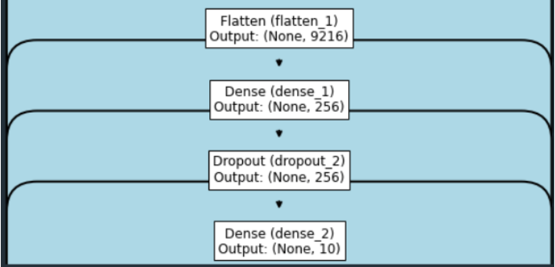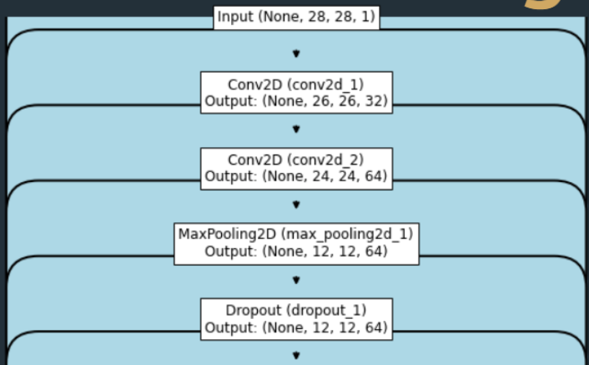

**Model summary:**

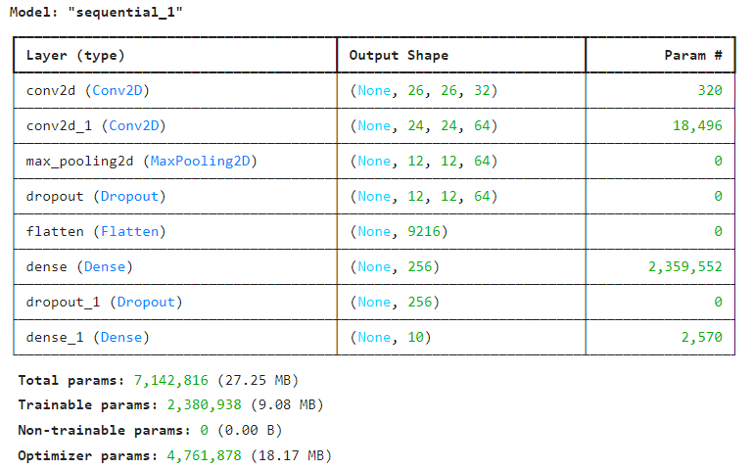



**Prediction:**

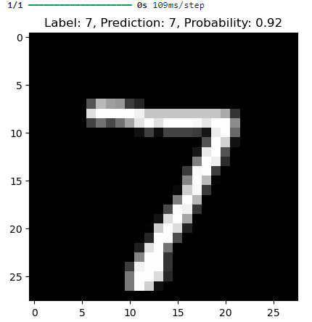

**Github Link:**

**https://github.com/Bhargava-Srinivasan-26/Deep_learning_elective/tree/main/Unit%201/Lab%204**